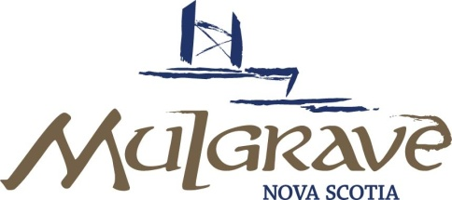

PUBLIC HEARING

DATE: February 21, 2023
TIME: 6:00 PM
PLACE: Mulgrave Professional Centre: 459 Murray Street, Mulgrave, N.S.
Attend In Person or Live Broadcast via Zoom
Join Zoom Meeting
https://us02web.zoom.us/j/88125403101?pwd=aXFBbUhLQTFEaG44eURqZ1IrVmFDUT09
Meeting ID: 881 2540 3101
Passcode: 456656
One tap mobile
+17806660144,,88125403101#,,,,*456656# Canada
+12042727920,,88125403101#,,,,*456656# Canada

Dial by your location
+1 780 666 0144 Canada
+1 204 272 7920 Canada
+1 438 809 7799 Canada
+1 587 328 1099 Canada
+1 647 374 4685 Canada
+1 647 558 0588 Canada
+1 778 907 2071 Canada
Meeting ID: 881 2540 3101
Passcode: 456656
Find your local number: https://us02web.zoom.us/u/k09FbP0eG
AGENDA
ITEM
1. |  | Call Meeting to Order
2. |  | Approval of Agenda / Addition of Agenda Items
3. |  | Agenda
Amendment to the Land-Use By-Law (Zoning Map)
- Oral Submissions
- Written Submissions

4. |  | Adjournment

